Class Time:
Names:

Confidence Intervals: Confidence Interval Lab II

Student Learning Outcomes:
The student will calculate the 90% confidence interval for proportion of students in this school that were born in this state.
The student will interpret confidence intervals.
The student will examine the effects that changing conditions has on the confidence interval.
Collect the Data
  - Survey the students in your class, asking them if they were born in this state. Let X = the number that were born in this state.
n = ________
x = ________
- Define the Random Variable P' in words.

- State the estimated distribution to use.

Find the Confidence Interval and Error Bound
- Calculate the confidence interval and the error bound.
  - Confidence Interval:

  - Error Bound:

- How much area is in both tails (combined)?

- How much area is in each tail? 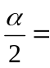

- Fill in the blanks on the graph with the area in each section. Then, fill in the number line with the upper and lower limits of the confidence interval and the sample proportion.
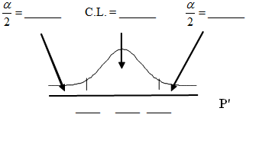
Describe the Confidence Interval
1. In two to three complete sentences, explain what a Confidence Interval means(in general), as if you were talking to someone who has not taken statistics.

- In one to two complete sentences, explain what this Confidence Interval means for this particular study.
- Using the above information, construct a confidence interval for each given confidence level given.
Confidence level | EBP / Error Bound | Confidence Interval
50%
80%
95%
99%

- What happens to the EBP as the confidence level increases? Does the width of the confidence interval increase or decrease? Explain why this happens.

